# Analysis and Conclusion

Our project focused on the number of data jobs before and after the COVID-19 pandemic, how many of those jobs are remote or onsite, the number of people employed in data positions and the average wages of those with data jobs before and after the COVID-19 pandemic. We looked at three resources: Bureau of Labor Statistics, Kaggle and Glassdoor, which provided us with an insight into our research questions.

The Bureau of Labor Statistics data concentrated on the years 2018 to 2021. Within those years, we looked at the number employed per year in data and all occupations, and the average annual wages of those employed in data and all occupations. The data analysis revealed that in data jobs and all occupations, the mean annual wages increased on an upward trend from 2018 to 2021. The r-values of both annual wages graphs (Figure 1 & 3) were above 0.92, which indicates a strong positive correlation. Contrastingly, the number employed decreased in data analyst positions in 2021, while they were at their peak in 2020. We can infer that the COVID-19 pandemic was the likely cause of the dramatic dip in the number of employed people across the board, especially in the number employed in all occupations since many jobs rely on onsite performances. In data analyst positions, the number employed didn’t significantly decrease in 2020 during the height of the pandemic, likely due to the position being able to be performed remotely. The r-value was 0.12 which was quite low though (Figure 2), so we attribute the scattered trend to the pandemic, as we infer a general trend of negative correlation during the pandemic for the number employed by year in all occupations.

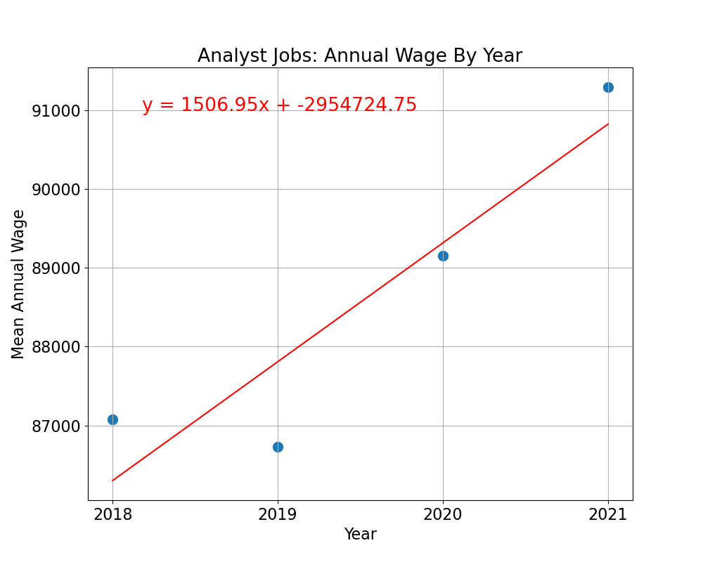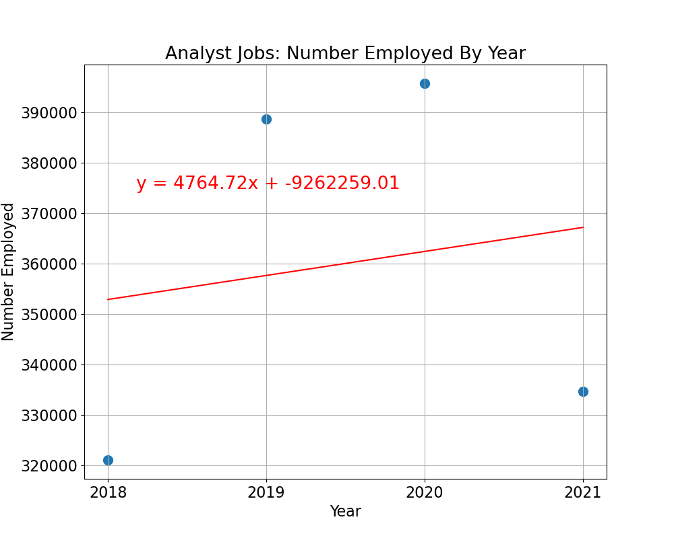  
 Figure 1 Figure 2

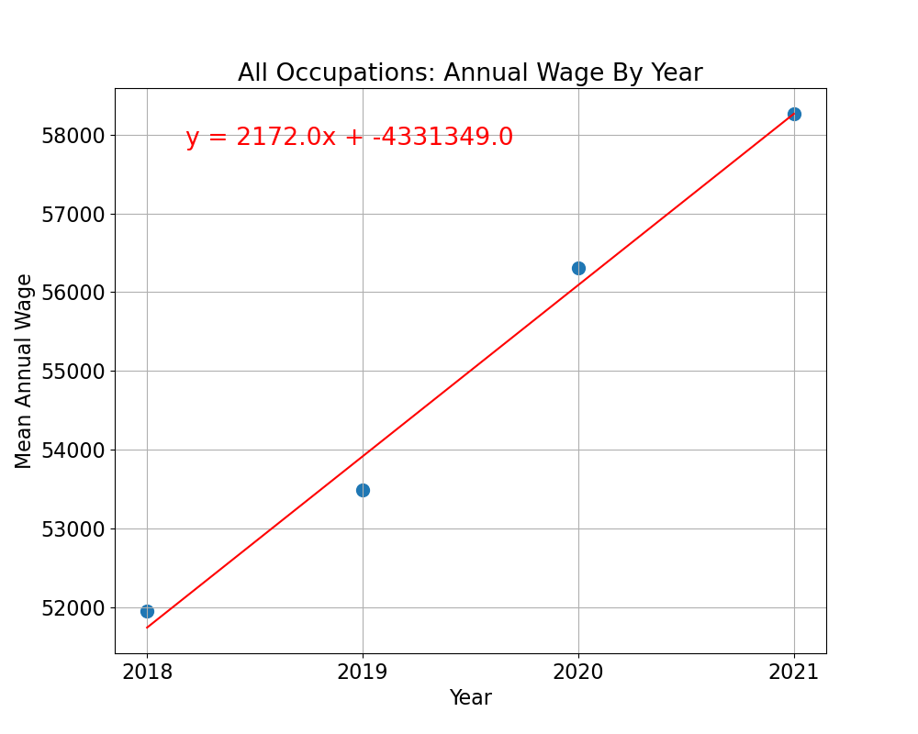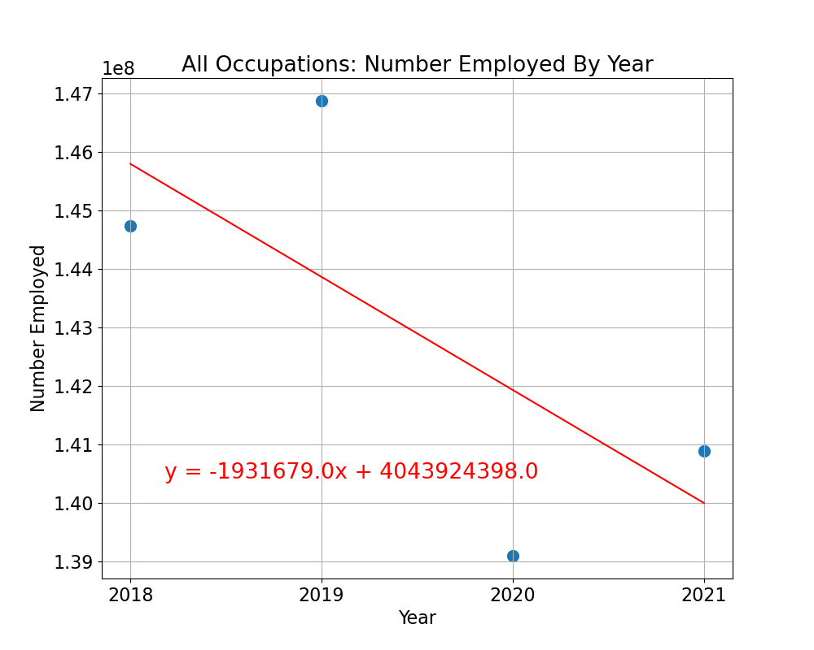

Figure 3 Figure 4

We analysed data from Kaggle for the years 2020 to 2022, which is during and after the pandemic, and it showed that the salaries of those with data jobs has varied since the COVID-19 pandemic. In 2020, bulk of data analysts make $150,000 or less (Figure 8) and 2021 saw the highest paid data analysts at almost $600,000 (Figure 9). The salaries of those employed in data positions varied greatly in 2022 (Figure 10).

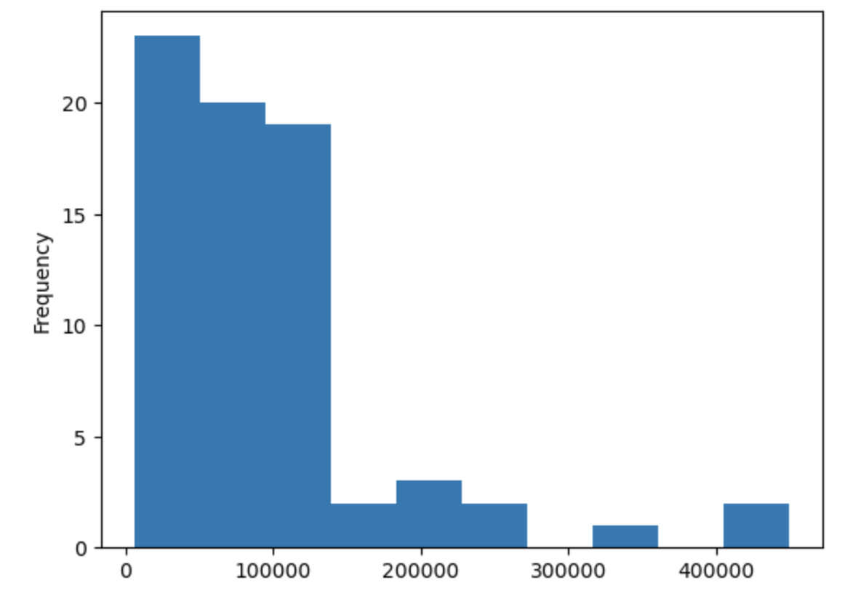

Figure 8

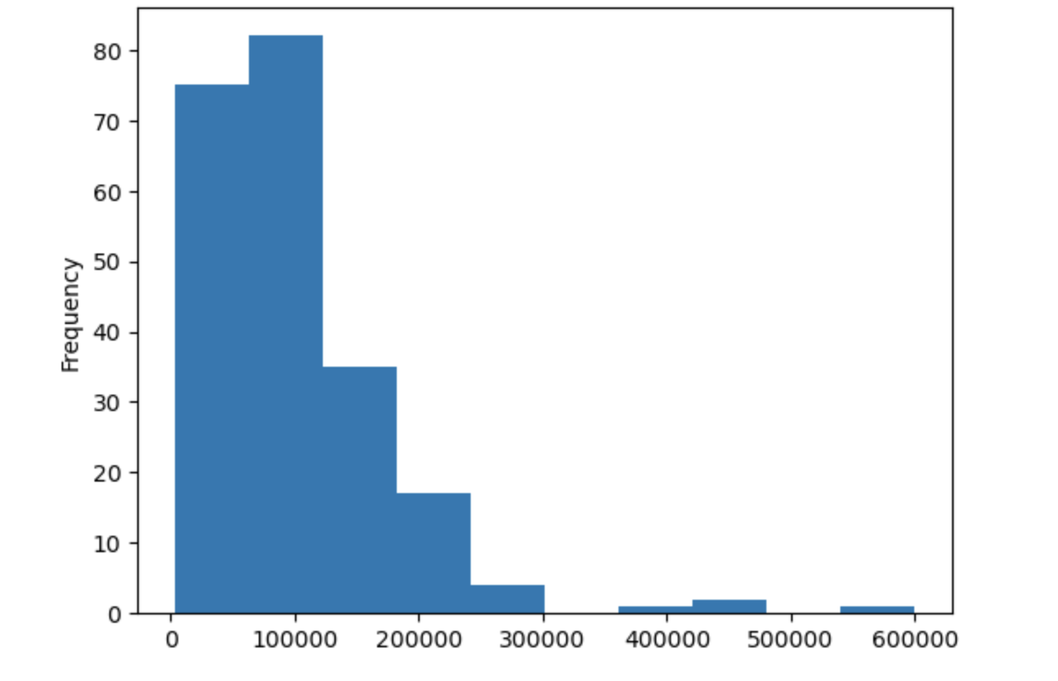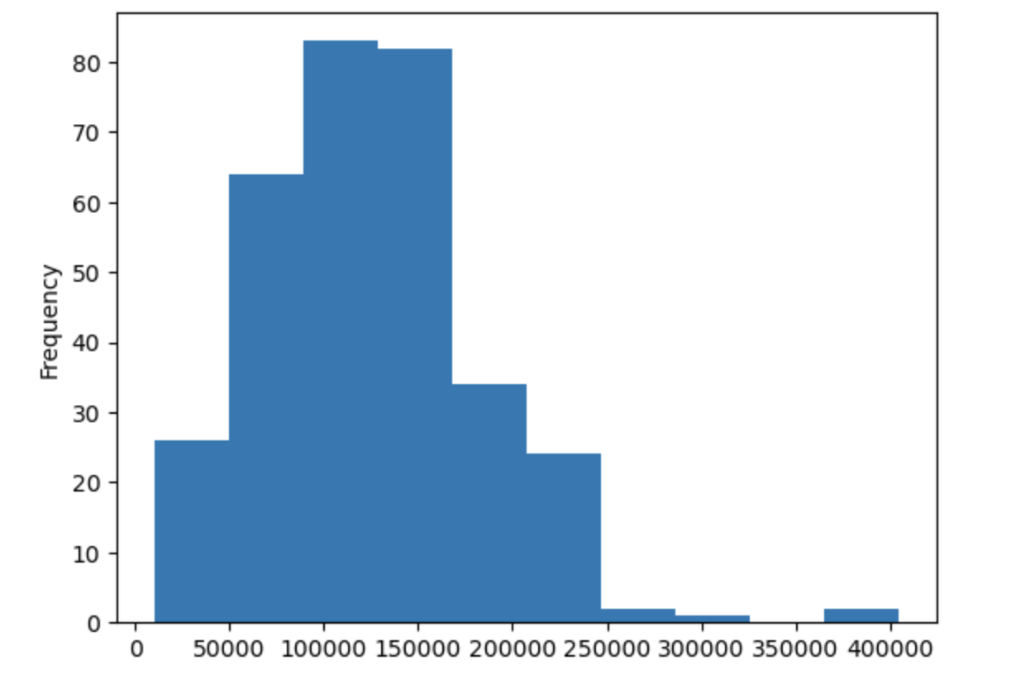  
 Figure 9 Figure 10

Glassdoor, a popular job board, allowed us to dive deeper into how many data positions were remote compared to onsite. Based on recent postings, onsite or non-remote jobs are rampant once again after the pandemic but show that there are more remote jobs available than ever before (Figure 6). Though more remote positions are available compared to before the pandemic, remote positions are still in the minority even in the data field (Figure 4). Washington, despite having fewer job postings than most states, has the most data job postings and offers a higher salary on average, followed not far by California (Figure 7). There are 1594 data job postings on Glassdoor with a mean salary of $113,409. The lowest data position listed a salary of $5162 and the highest had a salary of $297,000. The median salary was $110,783 for a data analyst position (Figure 5).

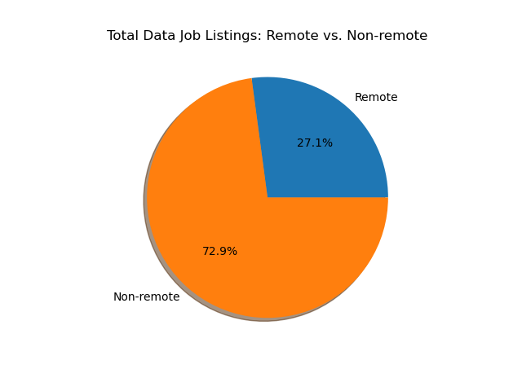 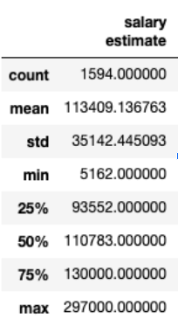  
 Figure 4 Figure 5

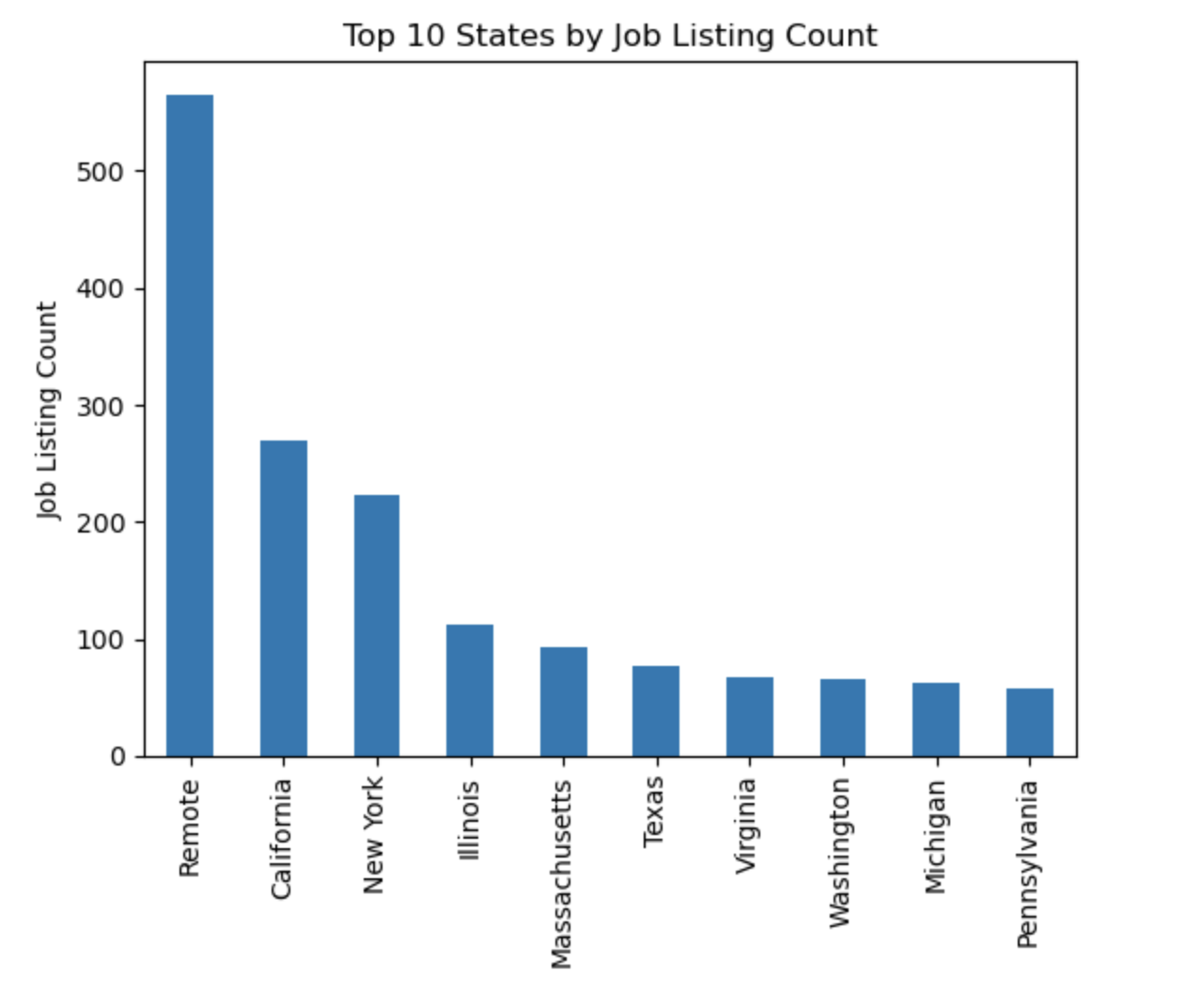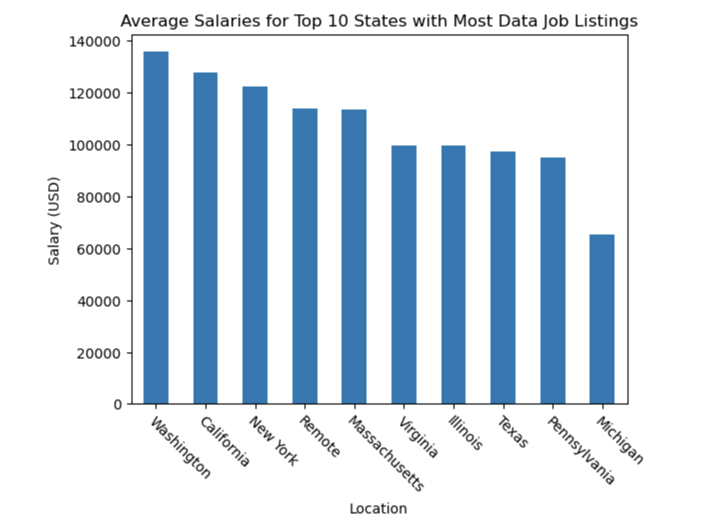

Figure 6 Figure 7

Overall, our findings show that the aftermath of the COVID-19 pandemic increased the number of data jobs and those in the data field, increased the number of remote positions but still primarily require employees to be onsite, and increased the average salary of data analysts.